**This is an article from Nursery World, published on 4th September 2023. Please, read through this article and produce a written discussion, of no more than 500 words, which summarises and reflects the key points made. Ensure you bring your written document to your appointment.**

**Number of children with speech and language challenges at record high**

Katy Morton  
**Monday, September 4, 2023**

**At least 1.9 million primary and secondary aged children are now estimated to be behind with speaking and understanding words.**

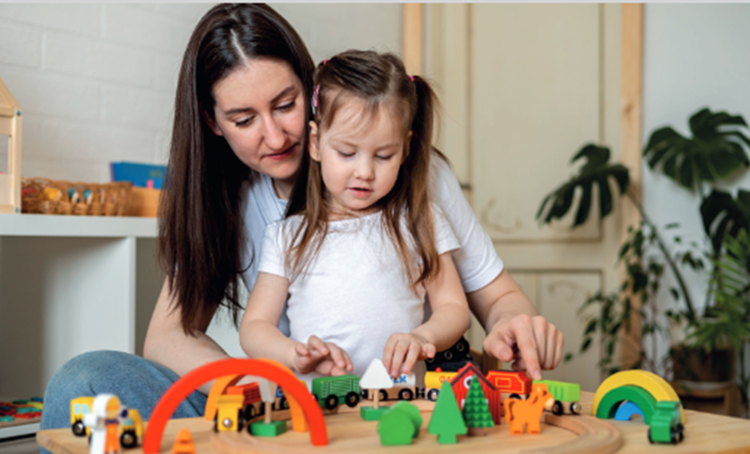The number of children with speech and language difficulties is at an all time high, according to Speech and Language UK

According to a new report from Speech and Language UK, one in five school-aged children now have speech and language challenges, the highest number ever recorded.

* [*EYFS changes bring risks to children's communication and wellbeing*](https://www.nurseryworld.co.uk/opinion/article/eyfs-changes-bring-risks-to-children-s-communication-and-wellbeing)

Key findings from *‘Listening to unheard children’*, which is based upon a YouGov survey of just over 1,000 adults, include:

* The number of children estimated to be behind with talking and understanding words has increased from 1.7 million last year to at least 1.9 million this year.
* 80 per cent of teachers surveyed think children in their classroom are behind with their talking and/or understanding of words.
* 73 per cent of teachers think that children’s speech and language is not prioritised by the Government.
* 53 per cent of teachers surveyed don’t believe they have sufficient training to support pupils’ speech and language in the classroom.

One school teacher said, *‘*There is definitely an impact and an increase in nonverbal children who can't articulate their needs or how they feel.

‘I'm seeing lots of children struggle with sentence construction/sounds/vocabulary. My experience is that this also impacts behaviour which in turn can impact the class.

‘It's not just one or two children either…There is no funding for support, and I firmly believe early intervention is what's needed on many levels.’

Speech and Language UK had previously warned that if the Government does not take urgent and specific action, and invest in targeted catch-up support and teacher training,  ‘significant’ numbers of children are at risk of falling behind.

**Call for action**

To improve the lives of 1.9 million children with speech and language challenges, the charity is urging Government and school leaders to take a number of actions, these include:

* Introducing a new tool for schools to track talking and understanding words at Key Stage 1 and 2 in the same way that every school tracks literacy and numeracy skills.
* Train all teachers and early years practitioners to spot children struggling with talking and understanding words and know how to help or where to refer them to.
* Produce guidance for schools about evidence-based tools and programmes for children with speech and language challenges of all ages that schools can deliver without specialist support.
* Fund a more ambitious campaign to give all new parents advice on speech and language development, in the same way they get information on feeding babies and vaccinations.
* Push the National Institute for Clinical Excellence to develop the first ever guidance on support for children with speech and language challenges in its 24-year history.

**'As we approach a General Election, all political parties must put speech, language and communication skills at the centre of their education plans.'**

Jane Harris, Speech and Language UK Chief Executive, said, ‘A lack of investment and prioritisation, and a difficult pandemic, has created an alarming number of children struggling with talking and understanding words.

‘Our education system has repeatedly failed to recognise that children with speech and language challenges will also struggle with reading, writing and maths. For the 1.9 million children affected, this impacts every aspect of their lives.

'They are more likely to fail in key subjects at school, more likely to be lonely, have mental health problems, and to be out of work as an adult.

 ‘As we approach a General Election, all political parties must put speech, language and communication skills at the centre of their education plans. 1.9 million children in the UK are relying on us to act. After all the challenges our education system has endured recently, they can’t afford to wait.’

Speech and Language UK is calling on children and young people with speech and language challenges, politicians, teachers, families and the public to join them in working towards creating a country where every child has access to the skills they need to face the future with confidence.