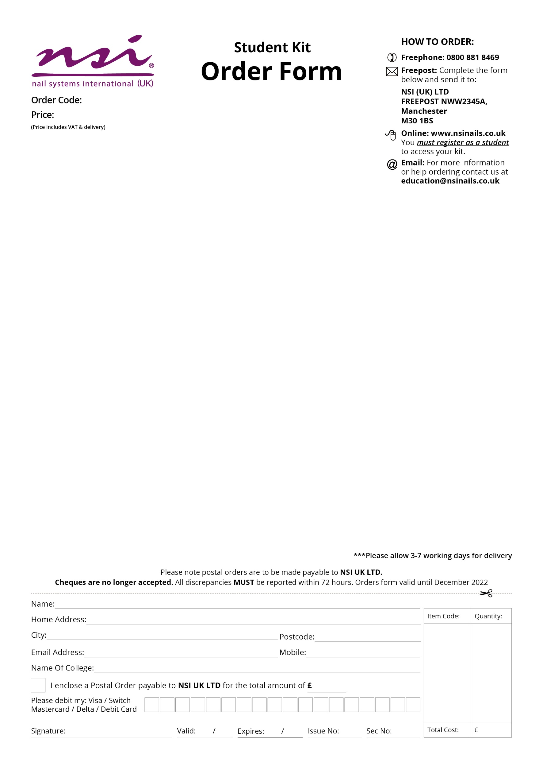­

Student Implement Kit

* No 8 Precision Brush
* Pink Nail Technician Implement Kit

Cuticle Pusher (Stainless Steel)

Economy Tip Cutters

Economy Cuticle Nippers

Cuticle Scissors

Perry Tweezers

* New NSI Catalogue

Craven College

CRA004

£57.00