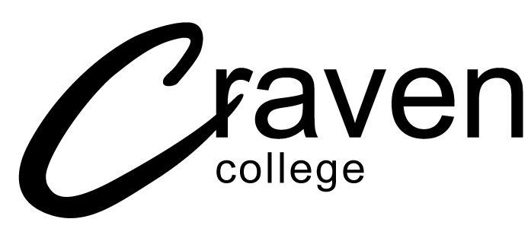

Application for Mitigation for students studying The Open University, Higher National Certificate / Diploma and ABC courses

GUIDELINES
An application for mitigation should be completed when, due to personal mitigating circumstances, you are unable to complete unit assessments (examination, presentation or coursework). This procedure is intended to establish a consistent and fair practice for all students across the College with regard to the recording and receipt of mitigating circumstances.

N.B. You must submit your Application for Mitigation prior to the assessment submission date. In exceptional circumstances completed forms may be accepted up to 14 days after the submission date. Any information received outside of this time period will not be considered, unless you can provide evidence that you were prevented from meeting the deadline by circumstances outside your control.

SECTION A
All applications for mitigation must be substantiated by independent documentary evidence, such as a medical certificate, letter from an employer, statement from a member of academic staff, statement of attendance from a counsellor, etc.
- Your name and course details
- The reason you are applying for mitigation, if this is of a sensitive nature a very brief note will suffice with a sealed envelope attached (please mark the envelope as confidential)
- The nature of the evidence you are providing to support your application e.g. medical certificate and the date for which that evidence applies
- Record the unit(s) for which the application is to be considered, the unit tutor, type(s) of assessment for all tasks in the unit and the assessment deadline date
SECTION B
This should specify in detail how your illness or personal circumstances are affecting your ability to undertake the assessments. Please remember to sign and date the application.

Following completion of the application form you must email the form to HE@craven-college.ac.uk

Incorrectly completed application forms will not be considered, and will be returned for proper completion.

The decision will be made by the Senior Academic Quality Officer (HE), wherever possible, within three working days of receipt of your application. Your Course Tutor will be made aware of the decision. It is your responsibility to follow up the decision by emailing HE@craven-college.ac.uk . Please keep a copy of your completed application form.

All applications for mitigation will be processed by the Senior Academic Quality Officer (HE) only. Please be assured that matters of a very personal nature will be treated with discretion and sensitivity.

Higher Education Application for Mitigation

- All sections of this form must be completed. The form should then be emailed to HE@craven-college.ac.uk. Please call 01756 243506 if you have any questions
- The independent documentary evidence must be attached.
- It is your responsibility to follow up the decision with the HE Team. Wherever possible, the decision will be made within three working days of receipt of the application
See guidelines for completion
SECTION A: DETAILS OF STUDENT, COURSE AND MITIGATION
- STUDENT NAME: |  | STUDENT Ref:
COURSE TITLE: |  | YEAR OF STUDY:
- REASON FOR APPLICATION (e.g. illness) Please provide details:
- NATURE OF EVIDENCE (e.g. Medical Certificate): | DATES FOR WHICH EVIDENCE APPLIES:
- I wish the evidence to be considered for the following assessment(s). Ensure you include all assessments which may be affected by your circumstances |  |  |  | FOR COMPLETION BY OFFICE
Module / Unit Title | Unit / Module Tutor | Assessment Type e.g. presentation, portfolio (include all tasks you would like to be considered) | Assessment Deadline Date | Mitigation Accepted/  Not Accepted

Section B
DETAILS OF CIRCUMSTANCES – EVIDENCE MUST BE ATTACHED.
This should specify in detail how your illness or personal circumstances have affected your ability to undertake the assessment(s). Please provide as much detail as possible as the decision will be based on the information you provide - you may attach a separate letter if you wish.

I confirm that the information provided is accurate and the evidence is genuine
STUDENT’S SIGNATURE:

FOR COMPLETION BY OFFICE
DATE APPLICATION RECEIVED:
APPLICATION FOR MITIGATION HAS / HAS NOT BEEN APPROVED
APPROVED BY SENIOR ACADEMIC QUALITY OFFICER:

