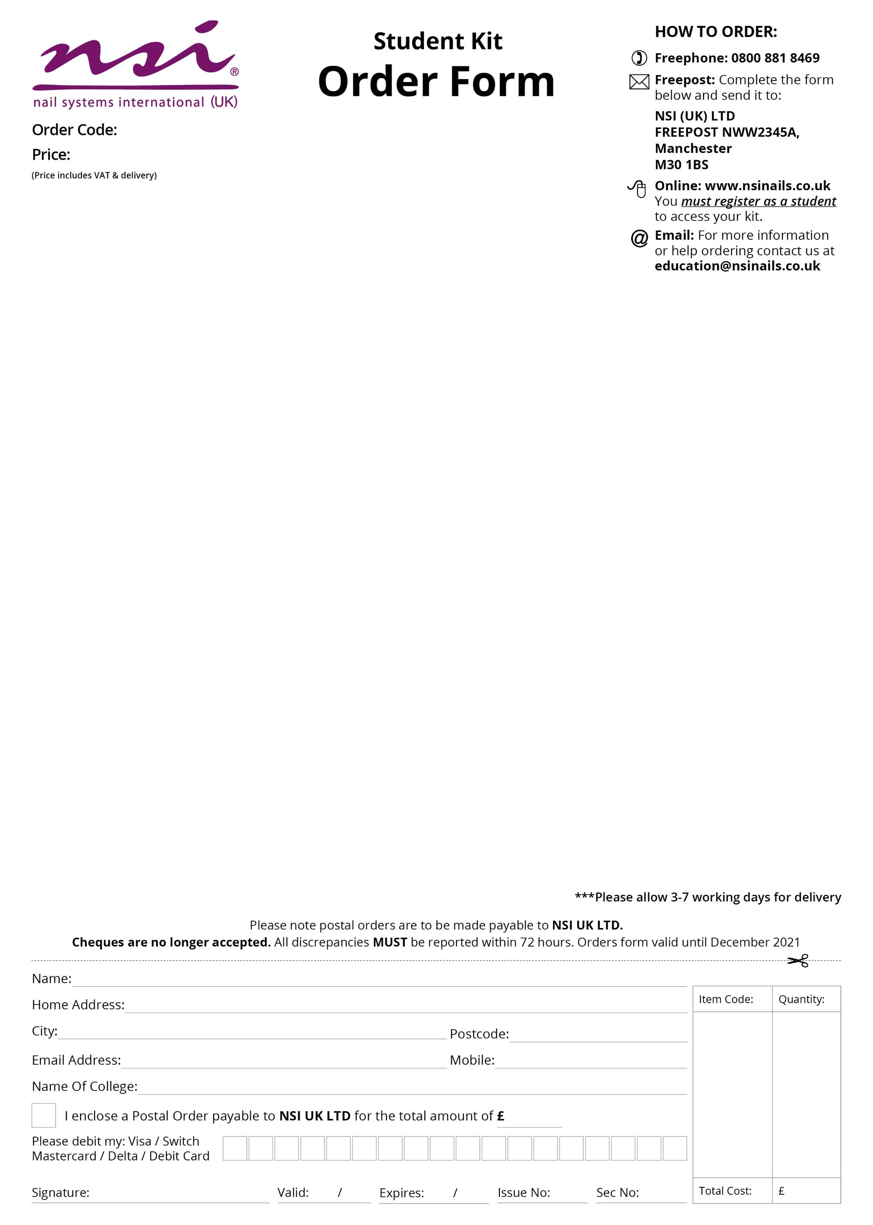­

Level 3 Nails Tech Kit

* Attraction Nail Liquid 4floz
* Attraction Sheer Pink Powder 40gm
* Attraction Rose Blush Powder 7gm
* Attraction Sample Kit:

Attraction Nail Liquid 2floz

Essential Bond (Acid Free) Primer 15ml

Attraction Radiant Pink Powder 7gm

Attraction Totally Clear Powder 7gm

Attraction Radiant White Powder 7gm

* No 8 Precision Brush
* No 5 Blue Compact Kolinsky Brush
* Black NSI HD 3D Compact Brush
* Dura Glue 7gm x3
* Dura 180/180 Grit File
* Dura 100/100 Grit File
* Nurture Oil 15ml
* Stackable Mixing Jars 5pk x2
* Small Dappen Dish with Lid
* Porcelain Dish with Lid
* Large Dappen Dish with Lid
* Safety Goggles
* Finger Rest
* New Complete Nail Technician Book
* Secrets Stiletto Forms 100ct
* Large Blue Vinyl Carrying Bag
* New NSI Catalogue

£150.00

College

CRA006